A Real-Time Research Project Report
on
EV BMS FIRE AND CHARGE PROTECTING SYSTEM
Submitted in partial fulfillment of the requirements for the award of the degree
of
Bachelor of Technology
in
CSE [Artificial Intelligence & Machine Learning]
by
V.NAKUL REDDY [247R1A66C6]
P.AKSHITHA [247R1A66A4]
A.SAMPATH [257R5A6610]
M.DEEPTHI [247R1A6695]
Under the guidance of
K.MADHU

Assistant Professor

DEPARTMENT OF CSE [Artificial Intelligence & Machine Learning]
CMR TECHNICAL CAMPUS
UGC AUTONOMOUS
Accredited by NBA & NAAC with ‘A’ Grade
Approved by AICTE, New Delhi and JNTU Hyderabad
Kandlakoya(V), Medchal Road, Hyderabad – 501401
April, 2026

DEPARTMENT OF CSE [Artificial Intelligence & Machine Learning]

CERTIFICATE
This is to certify that the Real-Time Research Project Report entitled EV BMS FIRE AND CHARGE PROTECTING SYSTEM being submitted by V.Nakul reddy [247R1A66C6] P.Akshitha [247R1A66A4] A.Sampath [257R5A6610] M.Deepthi [247R1A6695] in partial fulfillment of the requirements for the award of the degree of Bachelor of Technology in CSE [Artificial Intelligence & Machine Learning] to the Jawaharlal Nehru Technological University, Hyderabad is a record of Bonafide work carried out by them under my guidance and supervision during the Academic Year 2025 – 26.
The results embodied in this report have not been submitted to any other University or Institute for the award of any other degree.

K.MADHU Dr. S Rao Chintalapudi
Assistant Professor Head of the Department
Project Guide

ACKNOWLEDGEMENT
Apart from the efforts of us, the success of any project depends largely on the encouragement and guidelines of many others. We take this opportunity to express our gratitude to the people who have been instrumental in the successful completion of this project.
We take this opportunity to express my profound gratitude and deep regard to my guide Dr. K.Madhu, Assistant Professor, for his exemplary guidance, monitoring and constant encouragement throughout the project work. The blessing, help and guidance given by him shall carry us a long way in the journey of life on which we are about to embark.
We are also thankful to Dr. S Rao Chintalapudi, Head, Department of Computer Science and Engineering (AI&ML) for providing encouragement and support for completing this project successfully.
We are obliged to Dr. A. Raji Reddy, Director for being cooperative throughout the course of this project. We also express our sincere gratitude to Sri. Ch. Gopal Reddy, Chairman for providing excellent infrastructure and a nice atmosphere throughout the course of this project.
The guidance and support received from all the members of CMR Technical Campus who contributed to the completion of the project. We are grateful for their constant support and help.
Finally, we would like to take this opportunity to thank our family for their constant encouragement, without which this assignment would not be completed. We sincerely acknowledge and thank all those who gave support directly and indirectly in the completion of this project.
V.NAKUL REDDY [247R1A66C6]
P.AKSHITHA [247R1A66A4]
A.SAMPATH [257R5A6610]
M.DEEPTHI [247R1A6695]
ABSTRACT

This project focuses on the development of a comprehensive EV BMS (Battery Management System) Fire and Charge Protection System using the ESP32 microcontroller. The system is designed to enhance the safety of electric vehicles by simultaneously monitoring critical battery parameters and detecting external hazards. It integrates a voltage sensor to track the state of charge and prevent overcharging, alongside a fire sensor to detect thermal runaway or external ignition. Real-time status updates are provided via an LCD Display, while a buzzer acts as an immediate audio alarm in case of emergencies. By combining charge regulation with fire detection, this system provides a robust safety layer for lithium-ion battery packs.

LIST OF FIGURES

S. No | Figure Name | Page No
Figure 4.2 | Proposed Methodology | 12
Figure 4.3.1 | Class Diagram for EV BMS SYSTEM | 14
Figure 4.3.2 | Use Case Diagram for EV BMS SYSTEM | 15
Figure 4.3.3 | Component Diagram for EV BMS SYSTEM | 17
Figure 4.3.4 | Sequence Diagram for EV BMS SYSTEM | 18
Figure 4.3.5 | Activity Diagram for EV BMS SYSTEM | 19
Figure 7.1.1 | EV BMS SYSTEM - Arduino installation | 39
Figure 7.1.2 | EV BMS SYSTEM - Serial Port | 39
Figure 7.2.1 | EV BMS SYSTEM - Arduino IDE Toolbar | 40
Figure 7.2.2 | Waste Decomposer - ESP32 Module | 40
Figure 7.3.1 | EV BMS SYSTEM - Serial Monitor | 41
Figure 7.3.2 | EV BMS SYSTEM - LCD Display | 41

Table of Contents

Chapter Title | Page No
Abstract | iv
List of Figures | v
1. Introduction
1.1 Motivation | 1
1.2 Problem Statement | 1
1.3 Project Objective | 1
2. Literature Survey
2.1 Community Empowerment and Resource Access | 3
2.2 Government Schemes and Beneficiary Awareness | 3
2.3 Digital tools for Information Dissemination | 3
2.4 Impact of Technology on Rural Development | 4
2.5 Challenges in Reaching Underserved Communities | 4
2.6 Financial Sustainability of Social Initiatives | 4
2.7 Privacy, Data Security and Ethical Considerations | 4
2.8 Conclusion | 5
3. Requirement Specification
3.1 Software Requirements | 6
3.2 Hardware Requirements | 6
3.3 Functional Requirements | 7
3.4 Non-Functional Requirements | 7
4. System Design
4.1 System Design | 8
4.2 Proposed Methodology | 10
4.3 UML Design | 11
4.3.1 Class Diagram | 11
4.3.2 Use Case Diagram | 12
4.3.3 Component Diagram | 13
4.3.4 Sequence Diagram | 13
4.3.5 Activity Diagram | 14
4.4 Technology Description | 15
5. Implementation
5.1 Implementation | 16
5.2 Modules | 17
5.3 Executable Code | 19
6. Testing
6.1 Testing Definition | 21
6.2 Test Cases | 23
7. Results | 26
8. Conclusion | 29
9. Future Scope | 30
10. References | 31

1.INTRODUCTION
1.1 MOTIVATION
The motivation for developing an Electric Vehicle (EV) Battery Management System (BMS) with fire and charge protection is to ensure the safe and efficient operation of lithium-ion batteries used in EVs. These batteries store a large amount of energy and can become dangerous if they are overcharged, over-discharged, overheated, or short-circuited. Such conditions may lead to battery damage, reduced performance, or even fire hazards.
Therefore, a BMS is essential to continuously monitor important parameters such as voltage, current, and temperature of the battery cells. By controlling the charging and discharging process, the system prevents unsafe conditions and maintains the battery within its safe operating limits. The fire protection mechanism helps detect abnormal temperature rises and disconnects the battery or triggers safety actions to avoid thermal runaway.
In addition, the BMS balances the voltage of individual cells, improving battery efficiency and lifespan. Overall, the main motivation of the EV BMS fire and charge protecting system is to enhance battery safety, reliability, performance, and durability in electric vehicles.
1.2 PROBLEM STATEMENT
The increasing use of electric vehicles (EVs) has created a strong demand for safe and reliable battery systems. Lithium-ion batteries used in EVs are highly sensitive to conditions such as overcharging, over-discharging, overheating, and short circuits. These issues can lead to reduced battery performance, damage to battery cells, and in severe cases, fire hazards due to thermal runaway.
Many basic battery systems lack proper monitoring and protection mechanisms, which increases the risk of accidents and reduces the overall lifespan of the battery. Therefore, there need to develop an efficient Battery Management System (BMS) that can continuously monitor battery parameters such as voltage, current, and temperature, while providing effective fire detection and charge protection. Such a system will help prevent unsafe operating conditions, ensure safe charging and discharging, and improve the safety, reliability, and longevity of batteries used in electric vehicles.
1.3 PROJECT OBJECTIVE
The main objective of this project is to design and develop an Electric Vehicle (EV) Battery Management System (BMS) with fire and charge protection to ensure the safe and efficient operation of lithium-ion batteries. The system aims to continuously monitor important battery parameters such as voltage, current, and temperature to prevent unsafe conditions like overcharging, over-discharging, overheating, and short circuits.
Another objective is to implement a fire protection mechanism that can detect abnormal temperature rise and take immediate action to protect the battery and surrounding components. The project also focuses on improving battery performance and extending battery life by maintaining safe charging and discharging limits and balancing battery cells. Overall, the objective is to enhance the safety, reliability, and durability of battery systems used in electric vehicles.
Specific objectives include:
- To monitor the voltage, current, and temperature of the EV battery in real time.
- To develop a safe charging system that prevents battery overcharging.
- To implement over-discharge protection to avoid deep battery discharge and damage.
- To detect overheating conditions and activate a fire protection or shutdown mechanism.
- To design a system that can disconnect the battery during short circuits or abnormal conditions.
- To maintain battery operation within safe operating limits for improved performance.
- To increase the safety, efficiency, and lifespan of the EV battery.
- To provide alerts or indications when a fault or unsafe condition occurs

2.LITERATURE SURVEY
Several researchers have studied the importance of Battery Management Systems (BMS) in electric vehicles to improve battery safety, performance, and lifespan. A study by Sonam Pawar et al. proposed a BMS integrated with fire protection mechanisms that monitors battery parameters such as voltage, current, and temperature using sensors and a microcontroller. Their system detects abnormal temperature rise and automatically activates protective actions such as alarms and circuit disconnection to prevent thermal runaway and fire hazards. The results showed improved battery safety and reliable performance of the EV battery pack.
2.1 COMMUNITY EMPOWERMENT AND RESOURCE ACCESS
Community Empowerment and Resource Access refers to the process of enabling individuals and groups within a community to gain the knowledge, skills, confidence, and opportunities needed to improve their quality of life. It focuses on encouraging people to actively participate in decision-making processes and to take control of resources that affect their social, economic, and environmental well-being. Empowered communities are better able to identify their needs, solve problems, and work together to achieve sustainable development.
Access to resources is an important part of community empowerment. Resources may include education, healthcare, financial support, technology, infrastructure, and information. When communities have fair and equal access to these resources, they can improve employment opportunities, strengthen local economies, and promote social equality. Programs such as skill development, awareness campaigns, and support from government and non-government organizations help communities gain better access to these resources. Overall, community empowerment and resource access contribute to building stronger, self-reliant, and sustainable communities.
2.2 GOVERNMENT SCHEMES AND BENEFICIARY AWARENESS
Government Schemes and Beneficiary Awareness refers to the efforts made to inform and educate people about various welfare programs and policies introduced by the government for social and economic development. Governments launch many schemes related to education, healthcare, employment, housing, agriculture, and financial support to improve the living conditions of citizens, especially for economically weaker sections of society. However, many eligible beneficiaries are unable to take advantage of these schemes due to a lack of proper information .
2.3 DIGITAL TOOLS FOR INFORMATION DISSEMINATION
Digital Tools for Information Dissemination refer to the use of modern technology and online platforms to share information quickly and efficiently with a large number of people. These tools help organizations, governments, and communities spread awareness, provide updates, and deliver important messages to the public. Common digital tools include websites, mobile applications, email services, online portals, and social media platforms such as WhatsApp, Facebook, YouTube, and Twitter.
Through these platforms, information can be shared in the form of text, images, videos, and live updates.
2.4 IMPACT OF TECHNOLOGY ON RURAL DEVELOPMENT
Technology has also improved sectors such as agriculture through modern farming equipment, weather forecasting, irrigation systems, and digital marketplaces. Farmers can learn about new farming techniques, crop management, and market prices through digital tools. In addition, online education platforms provide students in rural areas with access to learning resources and skill development opportunities.
2.5 CHALLENGES IN REACHING UNDERSERVED COMMUNITIES
Challenges in Reaching Underserved Communities refer to the difficulties faced by governments, organizations, and service providers in delivering essential information, resources, and services to people living in remote or economically disadvantaged areas. One major challenge is the lack of proper infrastructure such as roads, electricity, and internet connectivity, which makes communication and transportation difficult. Limited access to digital devices and low digital literacy also prevent many individuals from using online platforms and digital services.
2.6 FINANCIAL SUSTAINABILITY OF SOCIAL INITIATIVES
To achieve financial sustainability, organizations often adopt strategies such as diversifying funding sources, including government grants, donations, partnerships with private organizations, and community contributions. Some initiatives also generate their own revenue through social enterprises, training programs, or service fees. Effective financial planning, transparent management of funds, and strong community participation are also important for sustaining these projects. When social initiatives are financially sustainable, they can continue providing services, expanding their impact, and supporting community development for many years.
2.7 PRIVACY, DATA SECURITY, AND ETHICAL CONSIDERATIONS
Data security involves using technical measures such as secure databases, passwords, and encryption to protect information from unauthorized access, misuse, or cyberattacks. Proper data management practices help prevent data leaks and maintain trust between organizations and the people they serve. Ethical considerations focus on using information responsibly and fairly. This includes obtaining consent before collecting data, ensuring transparency about how the data will be used, and avoiding misuse of information. Respecting privacy, maintaining strong data security, and following ethical practices are essential to protect individuals’ rights and ensure responsible use of technology and information.
3.REQUIREMENTS SPECIFICATION
This chapter gives an overview of the software and hardware components required for our project.
3.1 SOFTWARE REQUIREMENTS
The development and implementation of the EV Battery Management System require certain software tools for programming, simulation, monitoring, and testing of the system. A programming platform such as Arduino IDE is used to write, compile, and upload code to the microcontroller that controls the battery monitoring and protection functions. For circuit design and simulation, software like Proteus Design Suite or Multisim can be used to test the electronic circuit before hardware implementation.
Additionally, MATLAB may be used for data analysis, algorithm development, and simulation of battery performance. A serial monitoring tool within Arduino IDE helps display real-time data such as voltage, current, and temperature readings from the sensors. For documentation and report preparation, tools such as Microsoft Word and Microsoft PowerPoint are used to create project reports and presentations. These software tools help in designing, programming, testing, and presenting the EV BMS fire and charge protection system effectively.
3.2 HARDWARE REQUIREMENTS
The implementation of the Electric Vehicle (EV) Battery Management System (BMS) with fire and charge protection requires several hardware components to monitor and control the battery system effectively. A microcontroller such as Arduino Uno is used as the main controller to process data from sensors and manage protection mechanisms.
Voltage sensors are used to monitor the battery voltage, while current sensors such as ACS712 Current Sensor Module measure the current flowing through the battery. Temperature sensors like LM35 Temperature Sensor are used to detect overheating conditions in the battery pack.
For fire detection and safety, a flame sensor module can be included to identify fire hazards. A rechargeable lithium-ion battery pack acts as the power source for the system. Relay modules are used to automatically disconnect the battery during unsafe conditions such as overcharging or overheating. Additional components such as resistors, capacitors, connecting wires, and a breadboard are used for circuit connections. A display unit like a 16×2 LCD can be used to show battery parameters such as voltage, temperature, and system status. These hardware components work together to monitor battery conditions and ensure safe charging, discharging, and fire protection in the EV battery system.
3.3 FUNCTIONAL REQUIREMENTS
The EV Battery Management System (BMS) with fire and charge protection must perform several important functions to ensure the safe and efficient operation of the battery. The system should continuously monitor key battery parameters such as voltage, current, and temperature using appropriate sensors. It must detect unsafe conditions such as overcharging, over-discharging, overheating, and short circuits. When any abnormal condition is detected, the system should automatically activate protection mechanisms, such as disconnecting the battery using a relay to prevent damage or fire hazards.
The system should also provide real-time information about battery status through a display or monitoring interface. It must support safe charging by controlling the charging process and stopping it when the battery reaches its maximum safe voltage. In addition, the system should detect fire or extreme temperature rise and trigger alerts or safety actions. Overall, the functional requirements ensure that the BMS effectively monitors, protects, and manages the EV battery system to maintain safety, reliability, and optimal performance.
3.4 NON-FUNCTIONAL REQUIREMENTS
Non-functional requirements describe the quality, performance, and reliability standards that the EV Battery Management System (BMS) with fire and charge protection must meet. The system should be highly reliable and capable of operating continuously without failure to ensure the safety of the battery system. It should provide fast response time when detecting abnormal conditions such as overheating, overcharging, or short circuits so that protective actions can be taken immediately. The system must also be accurate in measuring battery parameters like voltage, current, and temperature to ensure proper monitoring and protection.
The BMS should be easy to use and maintain, allowing users or technicians to easily monitor battery status and perform maintenance when required. It should also be energy efficient so that the monitoring system itself consumes minimal power from the battery.

4. SYSTEM DESIGN
4.1 System Design
The system design of the Electric Vehicle (EV) Battery Management System (BMS) with fire and charge protection focuses on monitoring and protecting the battery from unsafe conditions. The system mainly consists of a microcontroller, sensors, protection circuits, and a display unit. A microcontroller such as Arduino Uno acts as the central control unit that processes the data received from different sensors and controls the protection mechanisms. There are two kinds of design documents developed in this phase:
1. Architecture Overview
Hardware Layer:
Built using Arduino Uno as the main microcontroller.
Battery monitoring is performed using sensors for voltage, current, and temperature.
Components include:
- ACS712 Current Sensor Module for current measurement
- LM35 Temperature Sensor for temperature monitoring
- Voltage sensor for battery voltage detection
- Flame sensor for fire detection
These components collect real-time data from the battery system.
Control Layer:
The Arduino Uno processes the sensor data and compares it with predefined safe limits.
Functions include:
- Detecting overcharging
- Detecting over-discharging
- Monitoring battery temperature
- Identifying fire or abnormal heat conditions
If unsafe conditions occur, the system activates protection mechanisms.
Protection Layer:
A relay module is used to automatically disconnect the battery during abnormal conditions.
Protection features include:
- Overcharge protection
- Over-discharge protection
- Over-temperature protection
- Fire detection and emergency shutdown
This layer ensures the battery operates within safe limits.
Display and Monitoring Layer:
A 16×2 LCD display shows real-time battery parameters such as:
- Battery voltage
- Current flow
- Temperature
- System status alerts
This helps users easily monitor the battery condition.
Software Interface:
The system is programmed using Arduino IDE, which allows uploading and debugging the control program in the microcontroller.

4.2 PROPOSED METHODOLOGY
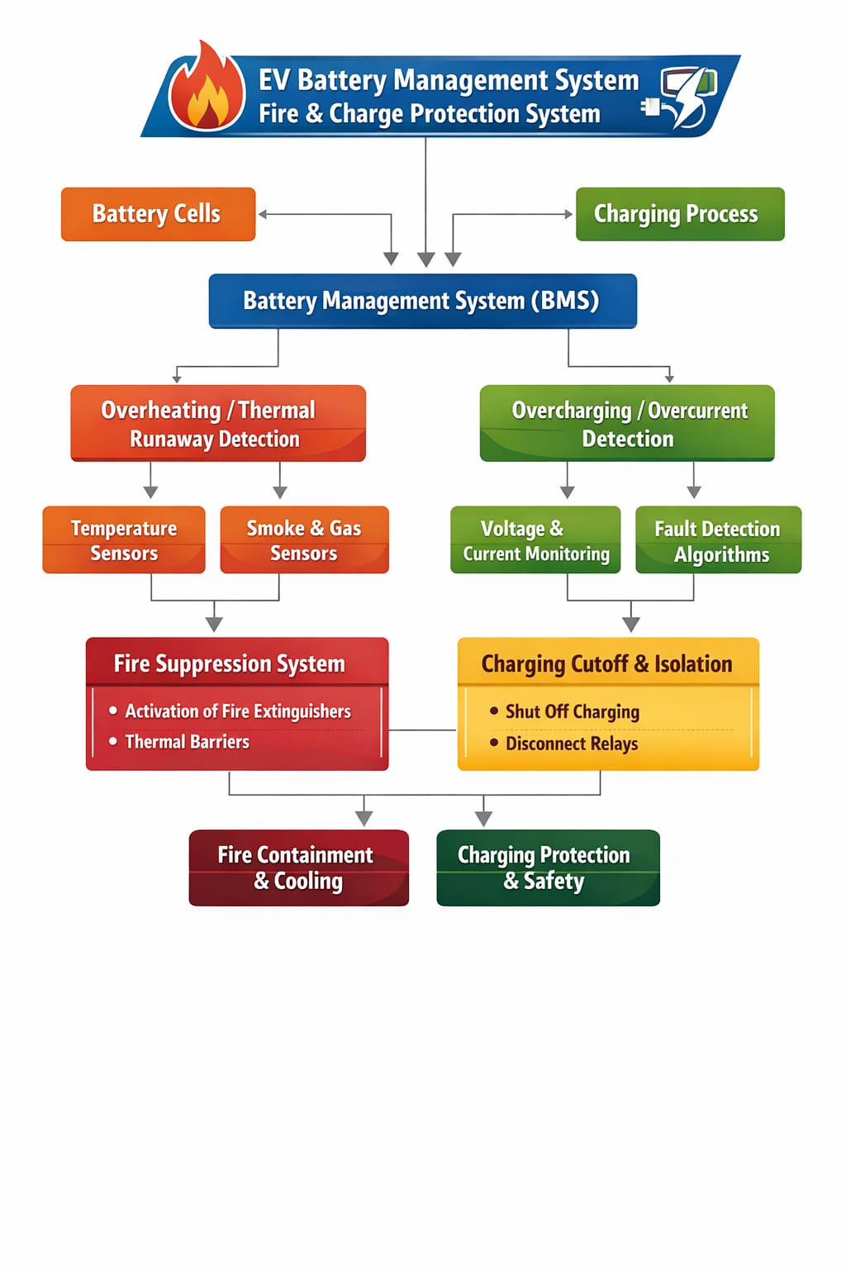
4.3 UML DESIGN
The Use Case Diagram represents the interaction between the User and the EV BMS System. The primary actor is the user (driver/technician) who monitors and interacts with the system.
4.3.1 CLASS DIAGRAM
The Class Diagram shows the structure of the system and relationships between components.
Main Classes:
- Battery → stores energy, provides voltage/current
- BMS Controller (ESP32) → main control unit
- Voltage Sensor → measures battery voltage
- Temperature/Fire Sensor → detects heat/fire
- Relay Module → controls charging (ON/OFF)
- LCD Display → shows system status
- Buzzer → gives alert signals
Relationships:
- ESP32 reads data from sensors
- ESP32 processes data and controls relay
- ESP32 sends output to LCD and buzzer
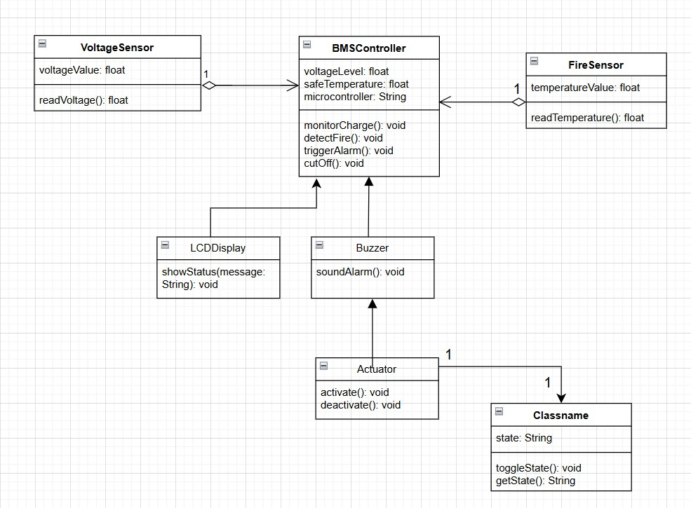
Fig 4.3.1: Class diagram
This diagram explains how all hardware components are interconnected and controlled by the microcontroller.
4.3.2 USE CASE DIAGRAM
Main Use Cases:
- Monitor battery voltage
- Detect temperature and fire conditions
- Receive alerts (buzzer & LCD display)
- Control charging (start/stop automatically)
- View system status
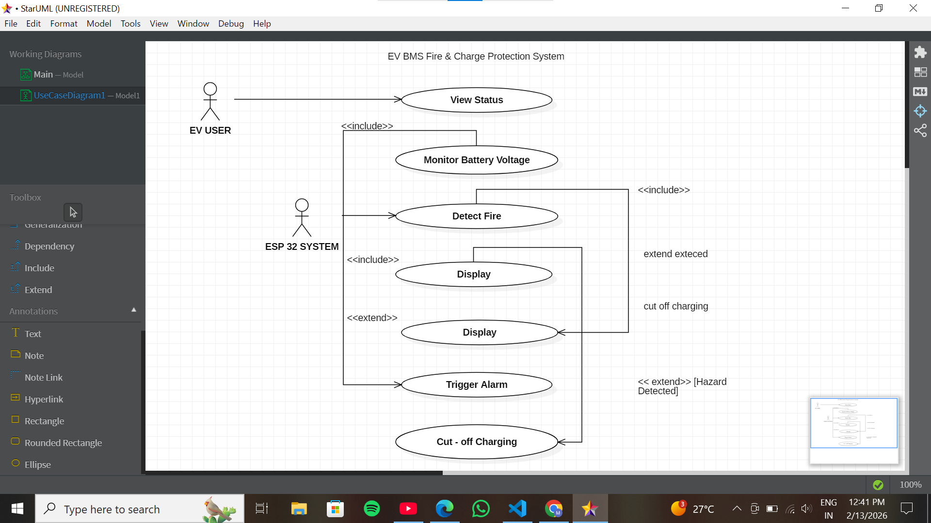
Fig 4.3.2 : Use Case Diagram
The user can observe system status through the LCD, while the system automatically handles safety operations like overcharge protection and fire detection without manual intervention.
4.3.3 COMPONENT DIAGRAM
The Component Diagram represents the high-level structure of the system and shows how different hardware and software components interact with each other.
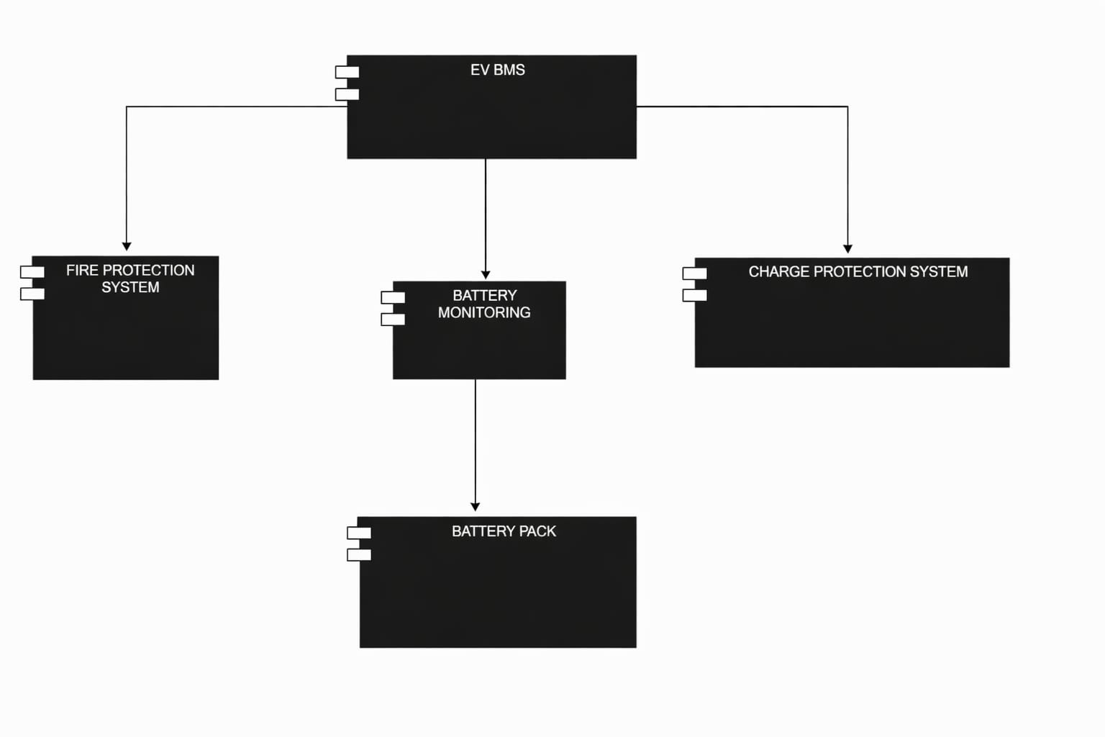
Fig 4.3.3: component diagram
4.3.4 SEQUENCE DIAGRAM
The Sequence Diagram shows the step-by-step working of the system over time.
Flow:
- System starts
- Sensors send data (voltage, temperature) to ESP32
- ESP32 processes the data
- If values are normal → display status on LCD
If abnormal condition detected:
- Trigger buzzer alert
- Display warning message
- Cut off charging using relay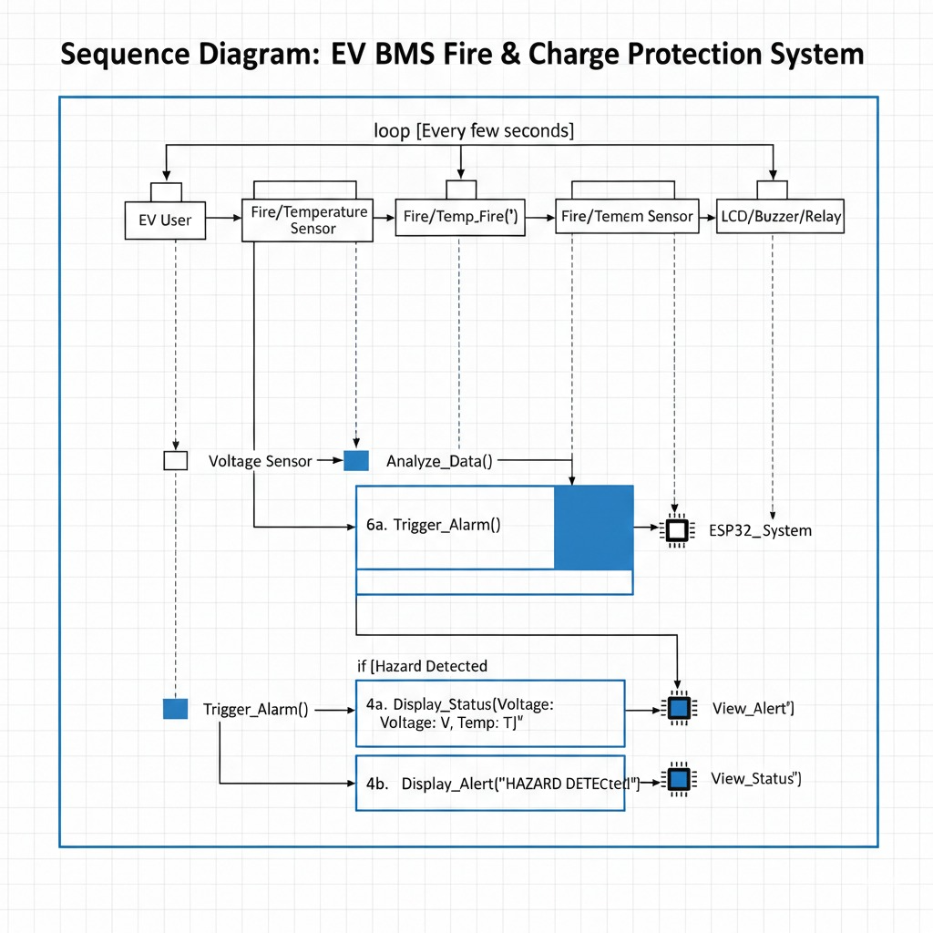
Fig 4.3.5: Sequence Diagram
4.3.5 ACTIVITY DIAGRAM
The Activity Diagram shows the workflow of the system.
Flow:
- Start → Read sensor values → Check conditions
- If normal → Continue monitoring
If abnormal → Trigger alert → Stop charging → End
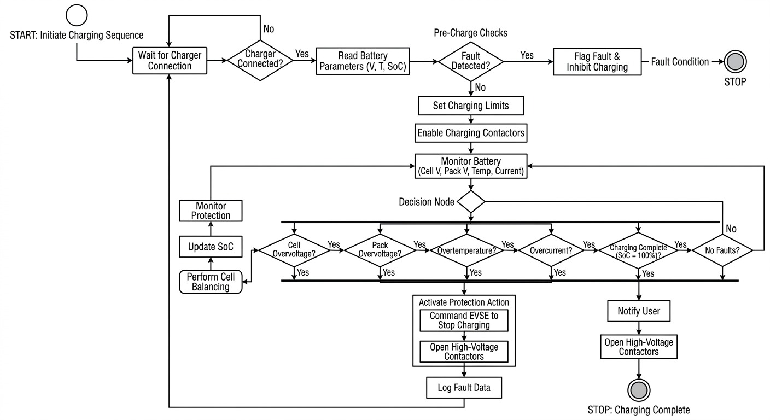
Fig 4.3.6: Activity Diagram
4.4 Technology Description
The Electric Vehicle Battery Management System (EV BMS) Fire and Charge Protecting System is an advanced safety and monitoring solution designed to prevent battery failures, overcharging, overheating, and fire hazards in electric vehicles. As lithium-ion batteries are highly sensitive to temperature, voltage, and current fluctuations, a reliable protection system is essential to ensure safe EV operation.
This system continuously monitors battery voltage, current, and temperature using sensors integrated with a microcontroller. The collected data is analysed in real time to detect abnormal conditions such as overcharging, short circuits, excessive temperature rise, or thermal runaway, which are common causes of battery fires.
5. IMPLEMENTATION
The implementation of the EV BMS Fire and Charge Protecting System involves integrating sensors, a microcontroller, protection circuits, and alert mechanisms to monitor and protect the electric vehicle battery.
1. Hardware Setup
System is built using a microcontroller (such as Arduino or ESP32) that acts as the central processing unit. Various sensors are connected to the controller to continuously monitor battery conditions.
Components Used
- Microcontroller (Arduino / ESP32)
- Temperature Sensor (LM35 / DS18B20)
- Voltage Sensor Module
- Current Sensor (ACS712)
- Relay Module / MOSFET
- Smoke or Gas Sensor (MQ series)
- Buzzer or Alarm
- LCD / IoT Module for monitoring
2. Battery Monitoring
Voltage and current sensors are connected to the battery pack to measure charging voltage and current levels. The microcontroller reads these values and compares them with predefined safe limits.
If the battery voltage exceeds the safe limit during charging, the system identifies it as overcharging.
3. Temperature Detection
Temperature sensors are placed near the battery cells to detect overheating. If the temperature crosses a threshold (for example 60°C), the system identifies a thermal risk that may lead to fire.
4. Fire and Smoke Detection
A smoke or gas sensor monitors the environment around the battery pack. If smoke or harmful gases are detected, the system interprets it as a possible fire hazard.

5. Protection Mechanism
When abnormal conditions occur, the microcontroller activates safety mechanisms:
- Cuts off charging through a relay or MOSFET switch
- Disconnects the battery from the power supply
- Activates a buzzer or alarm to alert the user
6. Alert and Notification
The system can display battery status on an LCD display or IoT dashboard. In advanced implementations, alerts can also be sent to a mobile device using WiFi or IoT platforms.
Integration and Testing
1. System Integration
After developing individual modules such as sensors, microcontroller, and protection circuits, all components are integrated into a single system. The temperature sensor, voltage sensor, current sensor, and smoke sensor are connected to the microcontroller, which acts as the central controller.
The relay or MOSFET switching circuit is integrated with the charging system to control the battery connection. An LCD display or monitoring interface is also connected to show real-time battery status such as temperature, voltage, and current.
Proper wiring and power supply connections are ensured so that all components communicate effectively with the microcontroller.
2. Software Integration
The microcontroller is programmed using embedded C / Arduino IDE to read sensor values and compare them with predefined safety limits.
The software performs the following functions:
- Continuously reads sensor data
- Processes battery parameters
- Detects abnormal conditions (overcharging, overheating, smoke)
- Activates protection mechanisms such as relay cut-off and alarm
3. Functional Testing
After integration, the system undergoes functional testing to verify that each component works correctly.
Tests performed include:
- Voltage monitoring test – Checking if the system detects overcharging conditions.
- Temperature test – Increasing temperature near the sensor to verify overheating detection.
- Smoke detection test – Testing whether the smoke sensor identifies fire hazards.
4. Performance Validation
The overall system performance is validated by running the system continuously and checking whether it can:
- Monitor battery parameters in real time
- Detect faults accurately
- Respond quickly with protective actions
Deployment
Deployment refers to the process of installing and implementing the developed system in a real-world electric vehicle environment to ensure effective battery monitoring and protection.
1. System Installation
developed hardware system is installed inside the electric vehicle battery compartment. Sensors such as temperature, voltage, current, and smoke sensors are placed near the battery cells to monitor the battery conditions accurately.
The microcontroller unit and relay protection circuit are securely mounted to control the charging and discharging process of the battery.
2. Battery Integration
The system is connected directly to the EV battery pack and charging circuit. The voltage and current sensors measure the battery parameters, while the relay or switching circuit controls the power supply to prevent overcharging or dangerous operating conditions.
3. Monitoring Setup
LCD display or IoT monitoring system is deployed to display real-time battery data such as:
- Battery voltage
- Battery current
- Battery temperature
- Fire or smoke alerts
This helps users and technicians monitor the battery health and system status.
4. Safety Mechanism Activation
The deployed system continuously monitors battery parameters. If abnormal conditions such as overcharging, overheating, or smoke detection occur, the system automatically:
- Cuts off the charging supply
- Disconnects the battery
- Activates an alarm or warning alert
5. Real-Time Operation
Once deployed, the system operates continuously during vehicle charging and usage. It ensures safe battery performance by preventing thermal runaway and reducing the risk of fire accidents.
Evaluation and Fine-Tuning
1. System Evaluation
After deployment and testing, the system is evaluated to determine its effectiveness in monitoring battery conditions and preventing fire hazards. The evaluation focuses on the system’s ability to accurately detect abnormal battery parameters such as high temperature, overvoltage, overcurrent, and smoke presence.
Sensor readings are observed and compared with actual values to verify the accuracy and reliability of the monitoring system. The response time of the protection mechanism, such as relay cut-off and alarm activation, is also evaluated.
2. Performance Analysis
The system performance is analysed under different operating conditions including:
- Normal charging conditions
- High temperature scenarios
- Overcharging conditions
- Smoke or fire simulation tests
This analysis helps determine whether the system can quickly detect faults and activate safety measures without delay.
3. Fine-Tuning of System Parameters
To improve performance, several parameters are fine-tuned:
- Adjusting temperature threshold values for overheating detection
- Calibrating voltage and current sensor readings
- Optimizing relay switching response time
- Improving sensor placement near battery cells for accurate monitoring
- These adjustments ensure that the system responds accurately and efficiently to dangerous conditions.
4. System Optimization
Software code is optimized to improve system stability and reduce processing delays. The microcontroller program is updated to ensure smooth data processing and reliable protection mechanisms.
5.2 MODULES:
1. Battery Monitoring Module
This module continuously monitors key battery parameters such as voltage, current, and state of charge. It ensures the battery operates within safe limits and helps in preventing overcharging and deep discharge.
2. Temperature & Fire Detection Module
This module uses temperature and fire sensors to detect overheating and fire hazards. It plays a critical role in identifying thermal runaway conditions at an early stage.
3. Control & Processing Module (ESP32)
This is the core module of the system. The ESP32 microcontroller processes data from all sensors, makes decisions based on predefined conditions, and controls the overall system operation.
4. Protection & Safety Module
This module ensures system safety by activating protective mechanisms such as:
- Cut-off relay to stop charging
- Isolation of battery during faults
- Prevention of overcurrent and short circuits
- 5. Alert & Notification Module
- This module provides real-time alerts to the user:
- LCD Display shows system status and warnings
- Buzzer gives immediate audio alerts during abnormal conditions
- 6. Power Management Module
- This module manages power distribution to all components and ensures stable operation of sensors, controller, and output devices.
- 7. Communication Module (Future Scope)
- Using ESP32’s Wi-Fi/Bluetooth capabilities, this module can enable:
- Remote monitoring
- Data transmission to mobile apps or cloud
- Smart notifications

5.3 EXECUTABLE CODE
import random
import time
# Safe Limits
MAX_VOLTAGE = 4.2 # Maximum battery cell voltage
MIN_VOLTAGE = 3.0 # Minimum voltage
MAX_TEMPERATURE = 60 # Maximum temperature in Celsius
def read_voltage():
# Simulated battery voltage
return round(random.uniform(2.8, 4.5), 2)
def read_temperature():
# Simulated battery temperature
return round(random.uniform(25, 80), 2)

def fire_detection(temp):
if temp > MAX_TEMPERATURE:
return True
return False
def charge_protection(voltage):
if voltage > MAX_VOLTAGE:
return "Overcharge - Charging Stopped"
elif voltage < MIN_VOLTAGE:
return "Low Voltage - Charging Required"
else:
return "Voltage Normal"
def bms_system():
print("EV Battery Management System Started...\n")
while True:
voltage = read_voltage()
temperature = read_temperature()
print("Battery Voltage:", voltage, "V")
print("Battery Temperature:", temperature, "°C")
# Charge Protection
charge_status = charge_protection(voltage)
print("Charge Status:", charge_status)
# Fire Detection
if fire_detection(temperature):
print("⚠ FIRE RISK DETECTED!")
print("Cooling System Activated")
print("Battery Disconnected for Safety")
else:
print("Temperature Safe")
print("-----------------------------")
time.sleep(3)
# Run System
bms_system()

6. TESTING
6.1 TESTING DEFINITION:
Testing of the Electric Vehicle Battery Management System (EV BMS) with Fire and Charge Protection was carried out to verify the proper functioning of the system under different operating conditions. The system was tested by simulating various battery voltage and temperature values to ensure that the monitoring and protection mechanisms work effectively. During normal operating conditions, where the battery voltage remained within the safe range (3.0V–4.2V) and the temperature was below the threshold limit of 60°C, the system operated normally without triggering any warning signals.
1. Unit Testing
Unit testing is performed to test individual modules of the EV Battery Management System separately. Each component such as the voltage monitoring module, temperature sensing module, fire detection module, and charge protection module is tested independently to verify that it functions correctly. For example, the voltage monitoring unit is tested by providing different voltage values to check whether it detects overcharging and low voltage conditions accurately. Similarly, the temperature module is tested by simulating different temperature levels to ensure that it triggers alerts when the temperature exceeds the safe limit.
2. Integration Testing
Integration testing is carried out to verify that all modules of the system work together properly. In this testing stage, the voltage monitoring, temperature sensing, fire detection, and protection mechanisms are combined and tested as a complete subsystem. The system is evaluated to ensure that when abnormal conditions occur, such as high temperature or overcharging, the corresponding safety mechanisms like stopping the charging process or activating cooling systems are triggered correctly.
3. System Testing
System testing is conducted to evaluate the overall performance of the EV BMS as a complete system. In this stage, the entire system including sensors, control logic, and safety mechanisms is tested under different conditions to ensure that it meets the functional requirements. Various scenarios such as normal battery operation, overcharging conditions, overheating, and low battery voltage are simulated to observe how the system responds.
4. Functional Testing
Functional testing ensures that the system performs all its intended functions correctly. This includes monitoring battery voltage, measuring temperature, detecting fire risks, and controlling the charging process. During testing, each function is verified to confirm that the system correctly performs monitoring and protection tasks as designed.
5. Performance Testing
Performance testing is conducted to evaluate the speed, responsiveness, and efficiency of the system. The response time of the system is measured to ensure that it can quickly detect abnormal conditions such as overheating or overcharging. The system should respond immediately by activating safety measures to prevent damage or fire hazards.
6. Validation Testing
Validation testing is performed to confirm that the developed system meets the project objectives and requirements. It verifies whether the EV BMS Fire and Charge Protection System performs as expected in real-world scenarios and provides adequate protection for the battery.
Test Results:
All the test cases mentioned above passed successfully. No defects encountered. Since, the grey box testing includes access to internal coding for designing test cases. Grey box testing is performed by a person who knows coding as well as testing.
Outcomes Possible:
Pass : The test case successfully validates the expected behavior of the application, indicating that specific functionality works as intended.
Fail: The test case fails to validate the expected behavior, indicating a defect or issue in the application. This outcome requires further investigation and fixing the identified problem.
Error: An error occurs during the test execution due to unexpected system behavior or exceptions. This could indicate a bug or potential issue that needs to be addressed.
Skipped: The test case is intentionally skipped from execution, typically due to low priority or specific conditions that prevent it from being applicable at the current stage of testing.

6.2 Test Cases
6.2.1 General Functionality
 | TC01 | Power ON the system | System initializes successfully,  LCD displays
 | Test Case ID | Description | Expected Result
 | TC01 | Power ON the system | System initializes successfully,  LCD displays
 | TC02 | Normal battery voltage  condition | Voltage displayed on LCD, no  alerts triggered
 | TC03 | Overcharging condition  (high voltage) | Charging is automatically cut off,  Warning displayed
 | TC04 | Low battery voltage  detection | Alert message shown on LCD indicating  Low voltage
TC05 |  | Temperature increase within  safe range | System monitors continuously without triggering alarm
 | TC06 | High temperature /  overheating detected | Buzzer activates, warning displayed, system  takes protective action
 | TC07 | Fire/Flame detection | Immediate buzzer alert, system indicates fire
 | TC08 | Overcurrent condition | Battery is disconnected automatically to  prevent damage
 | TC09 | Short circuit simulation | System isolates battery and stops operation  instantly
 | TC10 | LCD display functionality | Real-time parameters (voltage, status) are  displayed correctly
 | TC11 | Buzzer alert system | Buzzer activates during any abnormal
 | TC12 | Relay (cut-off mechanism)  operation | Relay disconnects charging during unsafe  conditions
 | TC13 | Sensor failure simulation | System shows error or no reading, alerts user (if programmed
 | TC14 | Continuous monitoring test | System runs continuously without failure and  updates data in real time
7. RESULTS
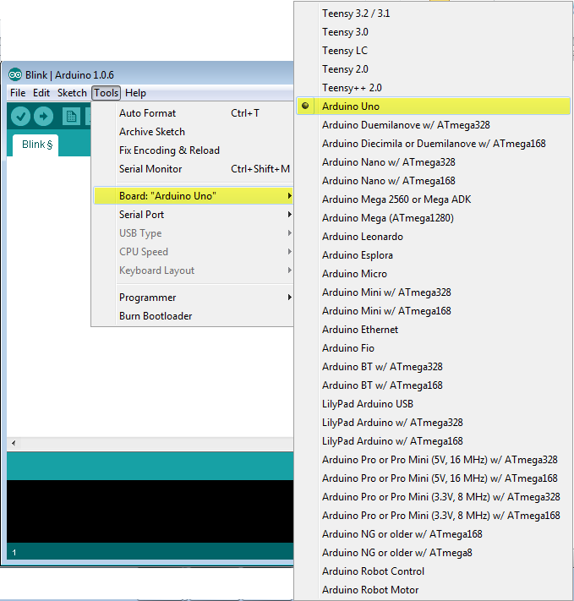
- After running the program we can see the following results
Figure-7.1.1 Arduino installation

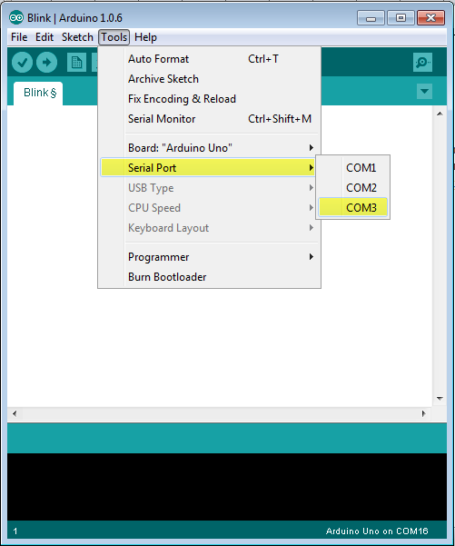
Figure-7.1.2 Serial Port
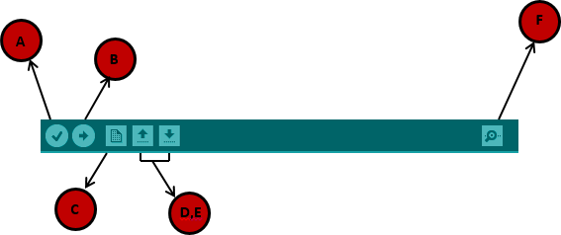
Figure-7.2.1 Arduino IDE Toolbar
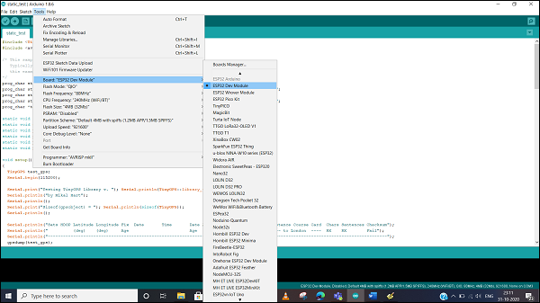
Figure-7.2.2 ESP32 Module
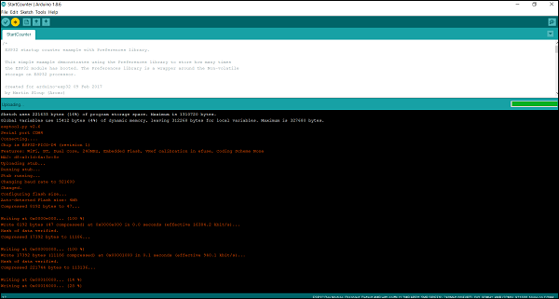
Figure-7.3.1 Serial Monitor
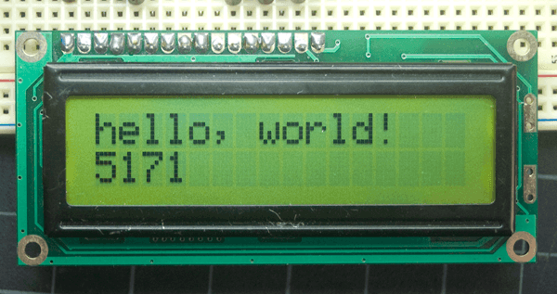
Figure-7.3.2 LCD Display

8. CONCLUSION
The EV BMS Fire and Charge Protection System provides an effective and reliable safety solution for electric vehicle battery packs. By integrating voltage monitoring and fire detection using the ESP32 microcontroller, the system ensures protection against overcharging and fire-related risks. Audible and visual alerts enable quick response during emergency conditions. This project demonstrates a practical approach to enhancing EV safety and can be further extended with IoT-based cloud monitoring and automatic power cut-off mechanisms for advanced applications.

9. FUTURE SCOPE
- IoT-Based Smart Monitoring
Integrate IoT technology to enable real-time battery monitoring and alerts through mobile or web applications, allowing users to track battery health remotely.
- AI-Based Predictive Maintenance
Implement Artificial Intelligence and Machine Learning algorithms to predict battery failures, thermal runaway, and performance degradation before they occur.
- Advanced Thermal Management System
Develop improved cooling techniques such as liquid cooling or phase-change materials to efficiently manage battery temperature and prevent overheating.
- Enhanced Fire Detection & Suppression
Upgrade the system with advanced fire detection sensors and automatic fire suppression mechanisms for faster and more reliable response.
- Mobile Application Integration
Design a user-friendly mobile app for real-time notifications, system status updates, and remote control of the BMS.
- Scalability for Large EV Systems
Expand the system to support large battery packs used in electric cars, buses, and fast-charging stations.
- Wireless Communication & Cloud Storage
Utilize Wi-Fi/Bluetooth capabilities of ESP32 for cloud data storage, analytics, and long-term performance tracking.
- Energy Optimization Techniques
Introduce smart charging algorithms to optimize battery life, reduce energy loss, and improve overall efficiency.

- REFERENCES
Reference Links
- J. Zhang et al., “Battery Management System for Electric Vehicles,” IEEE Transactions on Vehicular Technology, 2020.
- M. A. Hannan et al., “Lithium-ion battery charge and discharge control strategies,” Renewable and Sustainable Energy Reviews, 2018.
- Texas Instruments, Battery Management System Fundamentals, Application Report.
- ESP32 Technical Reference Manual, Espressif Systems.
- N. Omar et al., “Lithium Iron Phosphate Based Battery – Assessment of the Aging Parameters,” IEEE Vehicle Power and Propulsion Conference.
- P. Ramadass, “Battery Management Systems for Large Lithium-ion Battery Packs,” Artech House.
- Fire Sensor Module Datasheet, MQ Series Sensors Documentation.

